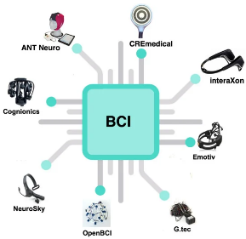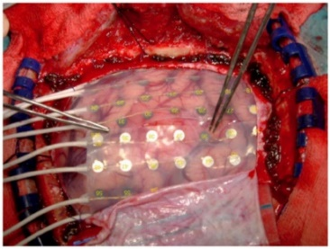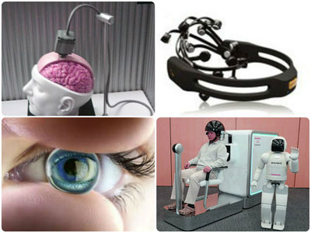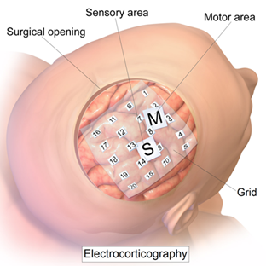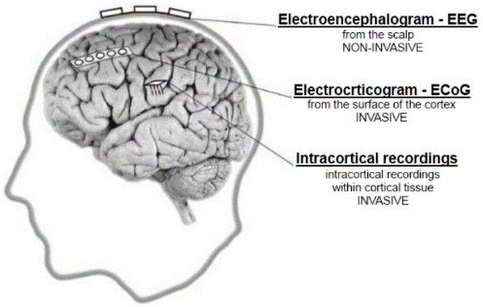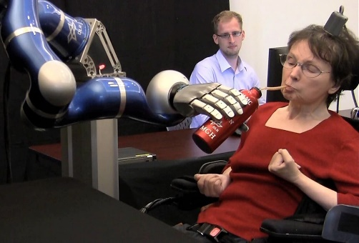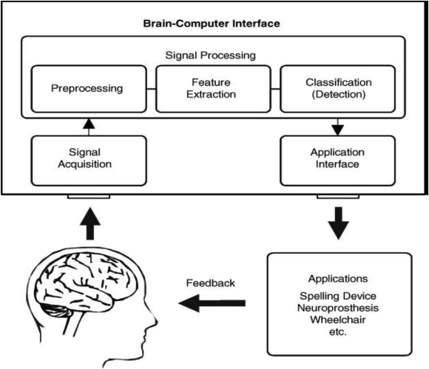Brain-computer interface

Fig. 7 Sample net of electrodes placed on the cortex surface. [11]

Fig.8. The most popular inexpensive, customer-grade EEG headsets. [11]

Fig.6. [13] Examples of the three types of BCI.

Fig.5. [10] Paralyzed patient moves robotic arm to drink for the first time in 14 years.

**Can BCI restore mobility movements for paralayzed people?**

In figure 5, researchers implanted a tiny electrode chip as small as a baby aspirin into the brain of a patient with a neurological disease, who suffered a stroke in her brain stem that left her in a “locked-in” state. [7] This meant all connections to the muscles below had been severed, leaving her paralyzed and unable to speak. The chip had been placed on motor cortex which is an area within the cerebral cortex of the brain that is involved in the planning, control, and execution of voluntary movements. [5] Doing this allows the chip to detect the signals generated from the person thinking a certain thought, for example in this scenario it would be the patient thinking about moving her arm. A computer would read these signals, interpret them and send specific messages to applications. [7] So, movement signals would be sent to the robotic arm. By using BCI, it allowed the patient to just by using her thoughts- gain mobility in being able to have a drink all on her for the first time in 14 years (figure 5) [10] However, not with this patient, there are still effects in the brain due to viral attacks, requiring excessive training for proper usage, high cost, slow speed, lack of better sensor modality, invasive BCIs are risky since it requires neurosurgery etc.[11] So developments in helping in the medical area are still improving.

Fig.3. ECOG, semi-invasive BCI. Electrode plate is kept in direct contact with the brain’s surface to measure the electrical activity of the cerebral cortex.

Fig.4. BrainGate Implant: created for brain implants, specifically for implanting BCI systems and making it easier. Develoepd by Cyberkinetics. [8]

[1] AndrewJoseph, C., 2022. BCI Guide. [online] EMOTIV. Available at: <https://www.emotiv.com/bci-guide/> [Accessed 3 June 2022]. [2] G. Pfurtscheller, C. Neuper, N. Birbaumer. Human brain-computer interface (BCI). A. Riehle, E. Vaadia (Eds.), A distributed system for distributed functions (2005), pp. 367-401 Motor Cortex in Voluntary Movements <https://www.ncbi.nlm.nih.gov/pmc/articles/PMC2891647/> [Accessed 17 May 2022] [3] Vaidyanathan, V., 2022. What Is A Brain Computer Interface?. [online] Science ABC. Available at: <https://www.scienceabc.com/innovation/what-is-a-brain-computer-interface.html#non-invasive-brain-computer-interface> [Accessed 17 May 2022] [4] Nicolas-Alonso, L. and Gomez-Gil, J., 2012. Brain Computer Interfaces, a Review. Sensors, [online] 12(2), pp.1211-1279. Available at: <https://www.mdpi.com/1424-8220/12/2/1211/html> [Accessed 4 June 2022]. [5] Guy-Evans, O., 2021. Motor Cortex Function and Location | Simply Psychology. [online] Simplypsychology.org. Available at: <https://www.simplypsychology.org/motor-cortex.html#:~:text=The%20motor%20cortex%20is%20an%20area%20within%20the,primary%20motor%20cortex%20and%20the%20nonprimary%20motor%20cortex.> [Accessed 5 June 2022]. [6] Nicolas-Alonso, L. and Gomez-Gil, J., 2012. Brain Computer Interfaces, a Review. [online] sensors. Available at: <https://www.ncbi.nlm.nih.gov/pmc/articles/PMC3304110/> [Accessed 5 June 2022]. [7] Vastag, B., 2012. Paralyzed woman moves robotic arm with her thoughts. [online] Washington post. Available at: <https://www.washingtonpost.com/national/health-science/paralyzed-woman-moves-robotic-arm-with-her-thoughts/2012/05/16/gIQAd52hUU_story.html> [Accessed 5 June 2022]. [8] Kawala-Sterniuk, A., Browarska, N., Al-Bakri, A., Pelc, M., Zygarlicki, J., Sidikova, M., Martinek, R., & Gorzelanczyk, E. J. (2021). Summary of over Fifty Years with Brain-Computer Interfaces-A Review. Brain sciences, 11(1), 43. Available at; <https://doi.org/10.3390/brainsci11010043> [accessed 5 june 2022]. [9] Haas, L., 2003. Hans Berger (1873–1941), Richard Caton (1842–1926), and electroencephalography. [online] J Neurol Neurosurg Psychiatry. Available at: <https://www.ncbi.nlm.nih.gov/pmc/articles/PMC7824107/> [Accessed 5 June 2022]. [10] Hochberg L.R., Bacher D., Jarosiewicz B., Masse N.Y., Simeral J.D., Vogel J., Haddadin S., Liu J., Cash S.S., Van Der Smagt P., et al. Reach and grasp by people with tetraplegia using a neurally controlled robotic arm. Nature. Available at: <https://www.ncbi.nlm.nih.gov/pmc/articles/PMC3640850/> [Accessed 5 June 2022]. [11] Mepits.com. 2014. BCI - Brain Computer Interface | Biomedical Tutorials | Mepits. [online] Available at: <https://www.mepits.com/tutorial/173/biomedical/bci-brain-computer-interface> [Accessed 2 July 2022]. [12] ssla-co-uk. 2019. Brain Computer Interface (BCI). [online] Available at: <https://www.ssla.co.uk/brain-computer-interface/#:~:text=Classification%20The%20main%20purpose%20of%20classification%20is%20to,however%20recently%20classification%20algorithms%20have%20gained%20immense%20popularity.> [Accessed 3 July 2022]. [13] Vasala, A., 2020. Introduction to Brain computer interface(BCI). [online] Medium. Available at: <https://medium.com/@aashishvinayvasala/introduction-to-brain-computer-interface-bci-18c77f93ac5a> [Accessed 3 July 2022]. [14] how2electronics. 2020. Brain Computer Interface (BCI) System Overview & Applications. [online] Available at: <https://how2electronics.com/brain-computer-interface-system-overview-applications/#:~:text=The%20term%20%E2%80%9Cnon-invasive%20Brain-Computer%20Interfaces%E2%80%9D%20encompasses%20all%20the,brain-to-computer%20stimulation%20without%20needing%20to%20penetrate%20the%20skull.> [Accessed 3 July 2022]. [15] NeurotechEDU. 2022. Intro to Brain Computer Interface. [online] Available at: <http://learn.neurotechedu.com/introtobci/> [Accessed 3 July 2022]. [16] RoboticsBiz. 2020. The history of Brain-Computer Interfaces (BCIs) - Timeline. [online] Available at: <https://roboticsbiz.com/the-history-of-brain-computer-interfaces-bcis-timeline/> [Accessed 3 July 2022]. [17] Kübler A.2019. The history of BCI: From a vision for the future to real support for personhood in people with locked-in syndrome. Neuroethics. <<https://link.springer.com/article/10.1007/s12152-019-09409-4>> [Accessed 3 July 2022]

**Future of BCI**

I think without even looking at how brain-computer interface is, we can see dating back to 2006 when technology wasn’t close to what it was now, for the accuracy to be above 70% in BCI is outstanding.[8] So simply imagine what now can be invented and be brought to such a degree in success, BCI is constantly developing with already creations being made to help paralyzed people walk move devices, helping people with speech impairments and people with hearing impairments.

It’s seen by scientists and research workers that as technology improves over the years, they’ll be able to bring out a more wide variety of BCI applications useful for society. Just like it’s shown in figure 4, BCI can also restore and augment human functions thereby improving the quality of living, like improving the accuracy of brain implants.[11] It can also provide jobs for disabled people that people would think to be impossible, like flying an aeroplane just by thinking and a blind driving a vehicle. In the medical sector, research workers are working on more precise equipment and the start of wireless BCI, with the possibility of being able to replace the robotic devices and directly bypass the signals to the nerves in the damaged part of the brain, thereby allowing the paralyzed patient to move their body completely. [11] As shown, it can be a big help to improving the quality of life.

**Types of BCI**

Non- invasive: This is any technology that doesn’t need to penetrate the skull for brain-to-computer, it mainly uses electrodes that are specifically placed onto certain areas of the scalp in order to record brain activity. [14]

Semi invasive: This is when electrodes are placed just on the exposed surface of the brain, with a common use being electrocorticography (ECoG) which measures electrical activity from the cerebral cortex. [15]

Invasive: This is when a device is implanted directly into the brain of a user, through a surgical implantation (neurosurgery). [3] Signals are detected from a single area of brain cells using a single BCI, and multiunit BCIs are used when wanting to detect signals from multiple areas.

**Background information**

Even though brain computer interface has only just become known in the last few centuries, the start of it dates back to the 19th century, when Richard Caton [8], an English physicist, recorded the first ever animals’ electrical signals and published his results in 1875 in the British Medical Journal. [9] Discovery of the electroencephalography was a move to the development of BCI systems which was first recorded by Hans Berger in 1924. [16] In 1998 Philip Kennedy implanted the first invasive BCI into human, and in 2004 Matt Nagle (1980–2007) was the first patient with implanted invasive BCI system, who had 3rd category quadriplegia with retained speaking ability. The 2000s brought a highly increased number of studies about the BCI systems [17]. In 2006 Leuthardt et al. proved ECoG to be an effective source for control signal in BCI Systems, achieving accuracy between 73% and 100% [8] already when technology wasn’t even at its peak. In 2010 around 220,000 people with a loss of hearing already had cochlear implants implanted as the neuroprosthetic device that aims to restore hearing.[16] And two years later there was two ground-breaking studies that showed how much BCI can do and its importance. Both studies showed how the BCI systems enabled neural arm control and arm movements restoration after paralysis [8] and the first one was carried out on monkeys [8] and the second was inspired by this and done on two humans. The first study the overall success rate for both animals using the neuroprosthesis was about 80%. The second study was on a 58-year-old female and 66 years old male, who were paralysed due to a stroke. Both were able to move robotic arms, so the applied BCI system restored partially their hand motor ability increasing their quality of life. [8] There are also creations such as an ‘ultrahigh bandwidth brain-machine interfaces to connect humans and computers’ founded by Elon Musk and others, as well as working on wearable devices to allow people to text just by thinking. Which would significantly help disabled people. [8]

[2] Fig.1 Components of a BCI system.

**Summary**

Brain-computer interface (BCI) is a technology that uses brain or nervous system data to control computers, machines, and external devices. [11] The end result is to be able to control devices just by our simple thoughts from our brain signals being transferred to the certain machine we want to use. It was originally made to help in the medical area for people with limited mobility, [1] more specifically people who are paralysed by neurological neuromuscular disorders, such as any spinal cord injury, brain stem stroke, or nerve disorders like multiple sclerosis. [6] There are different steps that form a standard BCI which are signal acquisition, pre-processing, feature extraction, classification and the control interface [2]. The signal acquisition stage would capture and measure brain signals using a sensor modality, and then they may also perform noise reduction to remove electrical noise and other unnecessary signal characteristics when amplifying the signal levels.[3] This allows the signals to be transmitted to a computer once digitized so they can be analysed. [4] Then for further processing, the signals need to be prepared in a suitable form which is what pre-processing is for. The feature extraction stage identifies the different information in the brain signals that have been recorded by analysing digitally and filters out irrelevant signals, so we can distinguish the signal features related to the person's intent. [4] This is a challenging task as brain signals are mixed with other signals coming from a finite set of brain activities that overlap in both time and space. [6] We then have classification which uses feature vectors that have been extracted from brain signals to recognize the user’s intention. [12] The device operation then provides feedback to the user finally which would complete the loop of BCI, e.g. cursor control, letter selection, robotic arm operation.[11]

Marim Sabah, Y12